# **BBot IDE V3 – Release**

|  |
| --- |
| Add A Northwest Command |
| Add A Southeast Command |

Silly Instructions:

1. Color Red for Northwest
2. Color Green for Southeast
3. The Most Votes Will Be Credited for Voting The Most Command added to Extension

Stomp, Stomp, Stomp Activity

1. Color The Boy With Every Color That Is Given
2. Color The Girl With Every Color That Is Given

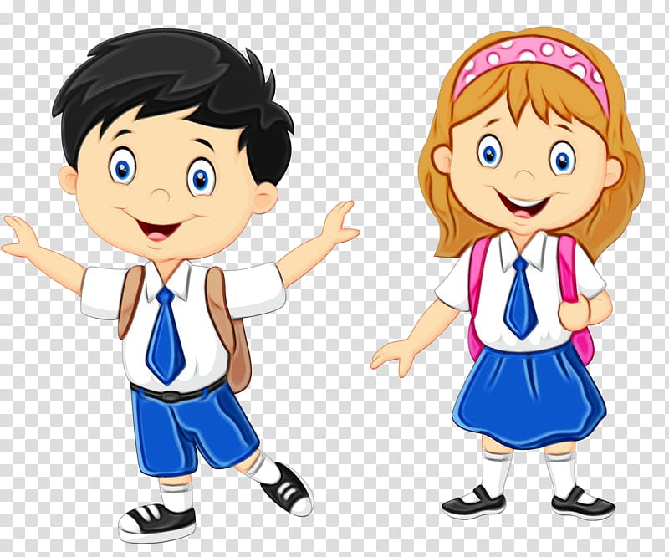

Boy: Northwest

Assigned Color: Flesh (skin) White (don’t color, shirt & socks), Blue (Pants), (shoes)

Girl: Southeast

Assigned Color: Flesh (skin) White (don’t color, shirt & socks), Red (Skirt), (shoes)